**IMS Engineering College, Ghaziabad**

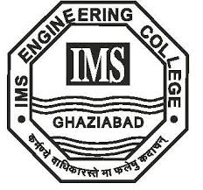

**Mini Project**

**Subject Name: Mini Project**

**Subject Code: KCS-354**

COURSE : B.Tech.

SEMESTER : 3rd

**By**

PRATEEKSHIT JAISWAL (2101430100130)

Department of Computer Science and Engineering

IMS ENGINEERING COLLEGE

NH-09, Adhyatmik Nagar, Ghaziabad-201015

(2022-23)